SSCO Module-Based Learning

**Trainee User Manual**

# Preface

This user manual is written for SSCO Module-Based Learning users who are designated as trainees. This manual will guide them on how to effectively use the SSCO Module-Based Learning application.

# Table of Contents

Preface 2

Table of Contents 3

Introduction 4

Getting Started 5

SSCO MBL - Trainee Interface 6

General Page Layout 6

Main Content 6

Sidebar 7

Trainee Home 8

Modules 9

Current Modules Page 10

Completed Modules Page 10

Available Modules Page 11

Viewing All Modules 12

Enrolling in Modules 13

Viewing a Module 15

Taking a Module Test 18

Search Module 19

Trainee Profile 20

Scheduled Tests 21

Index 25

# Introduction

SSCO Module-Based Learning is an e-learning web application primarily designed for the new hires of the SSCO department. Its goal is to enable the new employees to more effectively learn and understand the SSCO Department’s massive collection of documents by presenting information in easy-to-understand modules.

The list below includes some of SSCO Module-Based Learning’s features:

* SSCO Module-Based Learning allows trainees to view modules and enrol in them. These modules are designed to be easy-to-understand, allowing the trainees to readily comprehend the module content.
* After enrolling in a module, trainees can take the module’s comprehension test to reinforce what they learned.
* By organizing the trainees’ enrolled modules, SSCO Module-Based Learning allows the trainees to be able to easily manage the modules they are enrolled in.
* With scheduled tests that all trainees are required to take, administrators will be able to gauge how knowledgeable trainees are regarding certain topics.

This manual will provide detailed information on how to use the SSCO Module-Based Learning tool and how to make the most out of this application.

# Getting Started

Before using the SSCO Module-Based Learning application, please make sure that your web browser is a recent version of Google Chrome. Other browsers may have some problems in displaying the application correctly. JavaScript must be enabled because some of the application’s functions depend on it.

Navigate to the SSCO Module-Based Learning homepage (ask the administrator for the address).

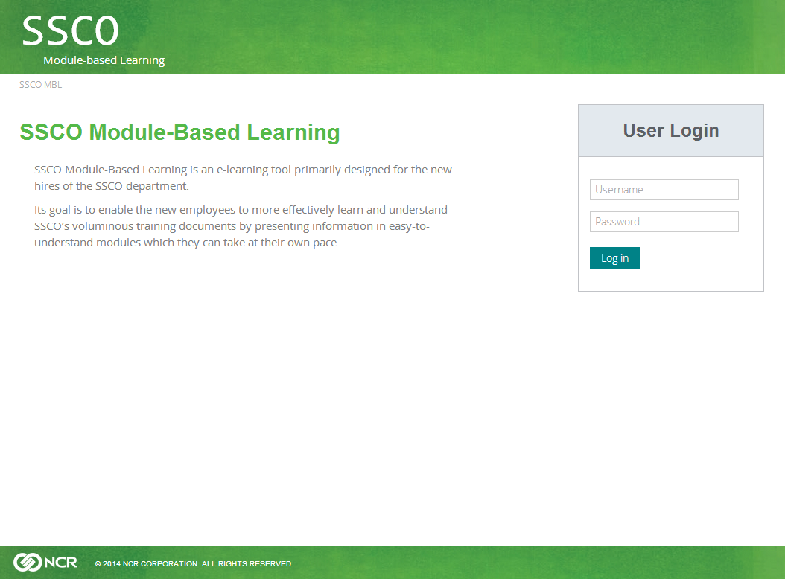

In the “User Login” form, enter your account details as given by the administrator. Click Login to enter the site.

# SSCO MBL - Trainee Interface

## General Page Layout

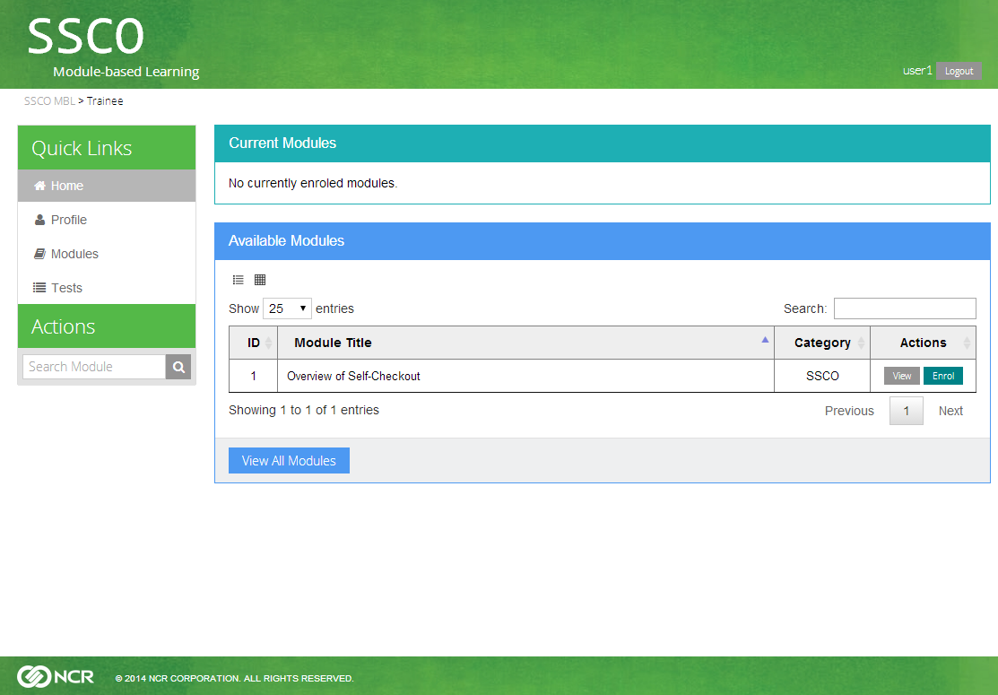

1. Main Content

(2) Sidebar

The picture above shows the home page, where you will go to right logging in. The home page, as well as other pages has the same main areas, which we will describe below.

1. Main content area
2. Sidebar - Quick links and Actions

### Main Content

The main content area is where your requested information will be shown. The content depends on what page you are in. For example, the trainee home page shows your currently enrolled modules, in addition to modules available for enrolment.

### Sidebar

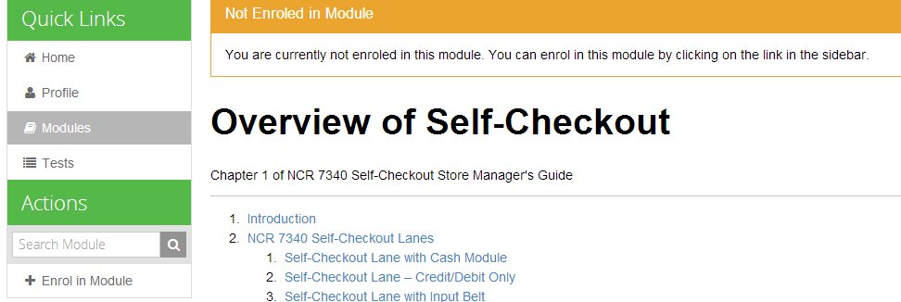

The sidebar provides useful links and actions. Quick Links provide links to the most commonly used functions of SSCO Module-based Learning. For trainees, you have Trainee Home (on page 8), Trainee Profile (on page 20), Modules (on page 9), and Scheduled Tests (on page 21). These pages will be discussed later.

Actions provide functions related to the page you are currently in. For example, when viewing an unenrolled module, you will be able to enrol in it by clicking on the link in the Actions pane. You can also search for a module using the search bar in the pane.

## Trainee Home

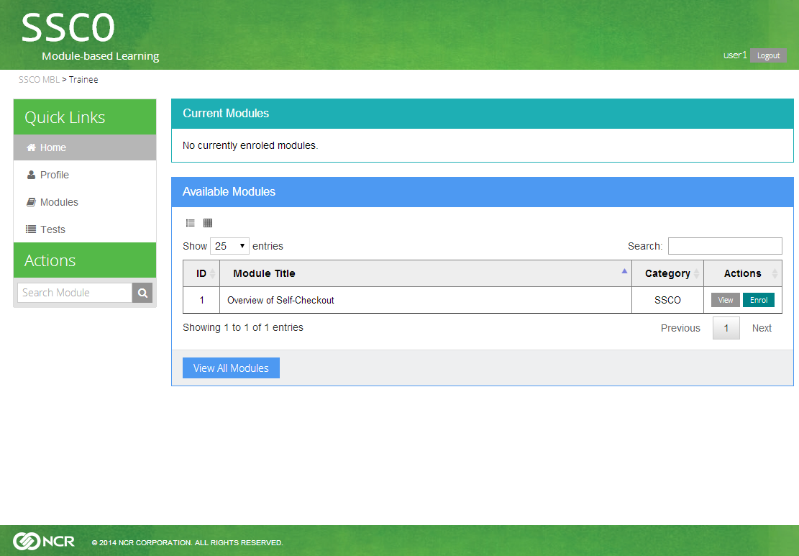

The trainee home page shows your currently enrolled modules and the modules available for enrolment. Since you won’t have any enrolled modules when you log in for the first time, the Current Modules panel will be empty. The Available Modules panel lists searchable modules you can enrol in. These panels will be discussed in details under the Modules (on page 9) section.

## Modules

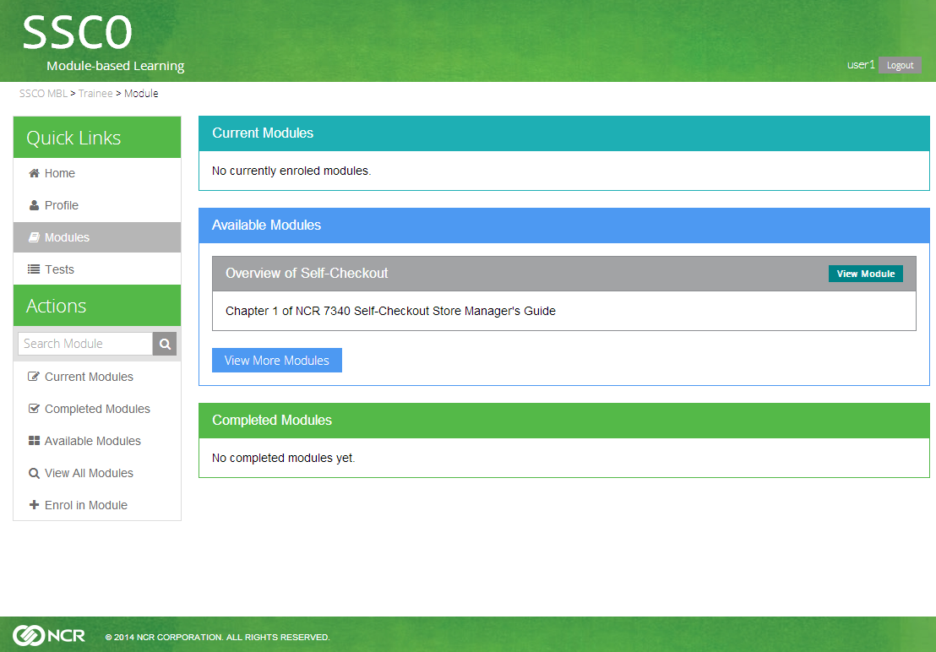

The Modules page contains all functions related to the SSCO modules. The main page contains your currently enrolled modules, modules available for enrolment, and completed modules.

The Modules page Actions pane contains functions related to module management. It provides the following options:

* Current Modules – Click on this to view enrolled modules that you haven’t completed yet. See “Current Modules” on page 10.
* Completed Modules – Click on this to view modules you have completed. See “Completed Modules” on page 10.
* Available Modules – Click here to view modules available for enrolment. Learn more about “Available Modules” on page 11.
* View All Modules – Click here to view all the modules. See “Viewing All Modules” on page 12.
* Enrol in Module – Click here to enrol in a module. See "Enrolling in Module” on page 13.

### Current Modules Page

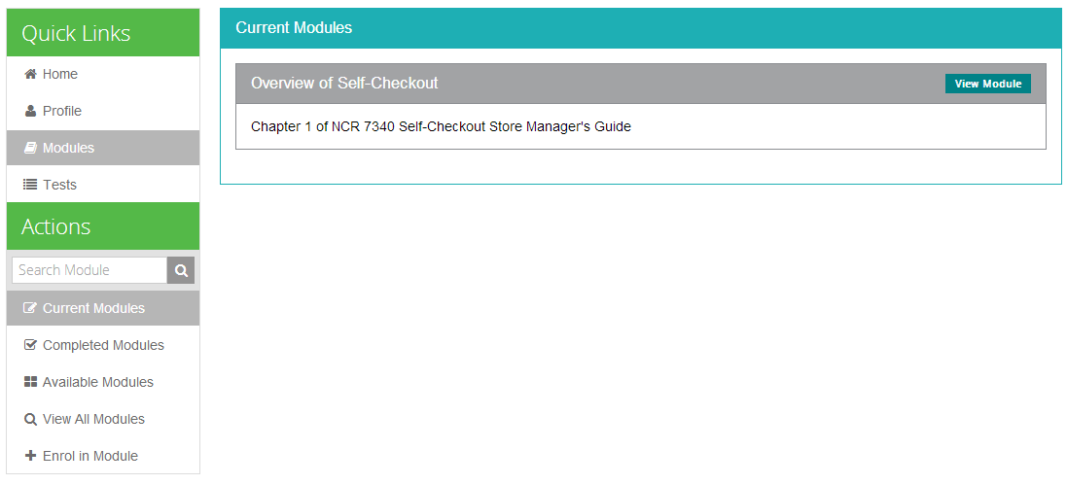

Right after you enrol in a module, it will be listed in Current Modules. You can view a module by clicking on the module’s title or on the View Module button. Viewing a current module allows you to take the test for that module (see “Viewing a Module - Current Modules” on page 16 for more information).

### Completed Modules Page

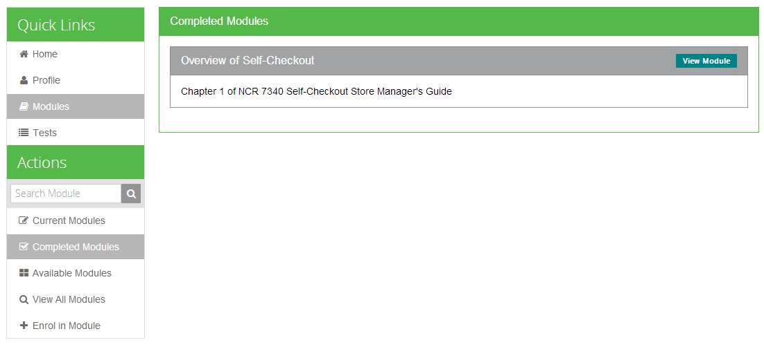

This page lists all modules that you have completed. A completed module means that you have already taken the module’s comprehension test. Viewing a completed module allows you to reenrol in the module or retake the test (see “Viewing a Module - Completed Modules” on page 17 for more information).

### Available Modules Page

The Available Modules panel contains all modules you can enrol in. In the Modules’ main page, you can only see up to three random available modules. By clicking on the View More Modules button, you can view every module that you can enrol in. You can view the modules in two modes: List View and Grid View.

#### Available Modules – List View

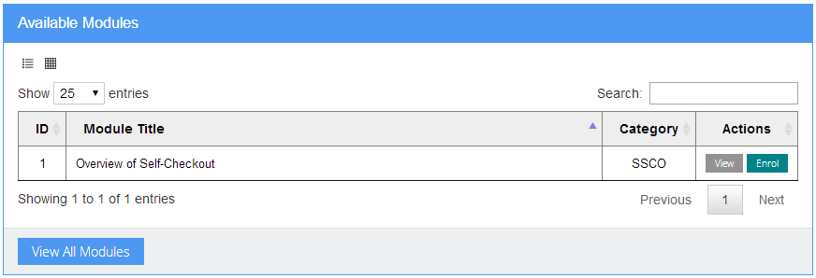

List View

In the default list view, module entries are listed in a table with their corresponding actions in the rightmost column. You can view the module before enrolling, or you can enrol in it directly. You will also be able to search for modules or their content by using the search bar at the upper-right corner of the panel.

#### Available Modules – Grid View

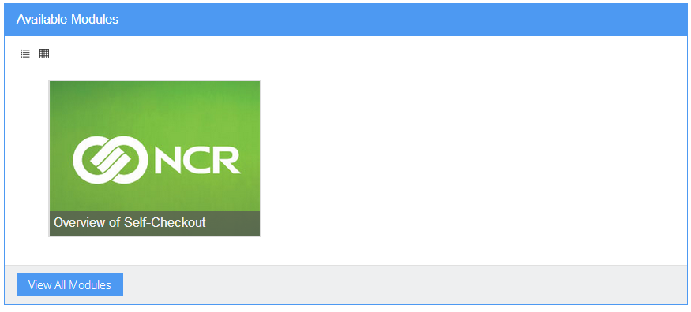

Grid View

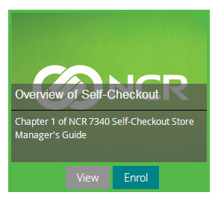

The grid view presents the modules as clickable thumbnails. When you click on a module, you will be see its description and be able to view or enrol the module using the buttons below the description.

### Viewing All Modules

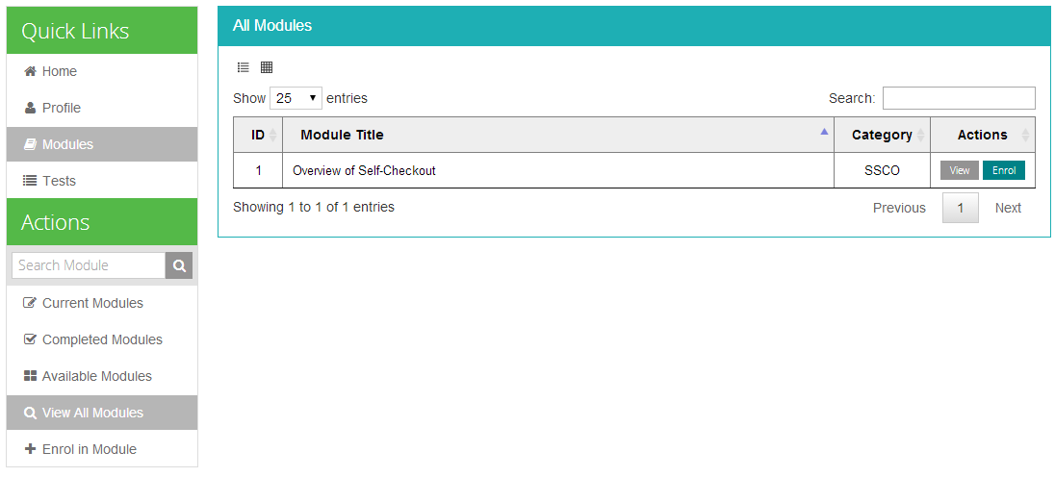

The View All Modules page lists all of the modules in the database. Like the Available Modules page, you can view the modules in List or Grid view.

### Enrolling in Modules

You can enrol in a module using three different ways: through the Enrol in Module page, by directly clicking the Enrol button in the Module List View, or by clicking Enrol in Module in the Actions pane when viewing a module.

#### Enrol in Module Page

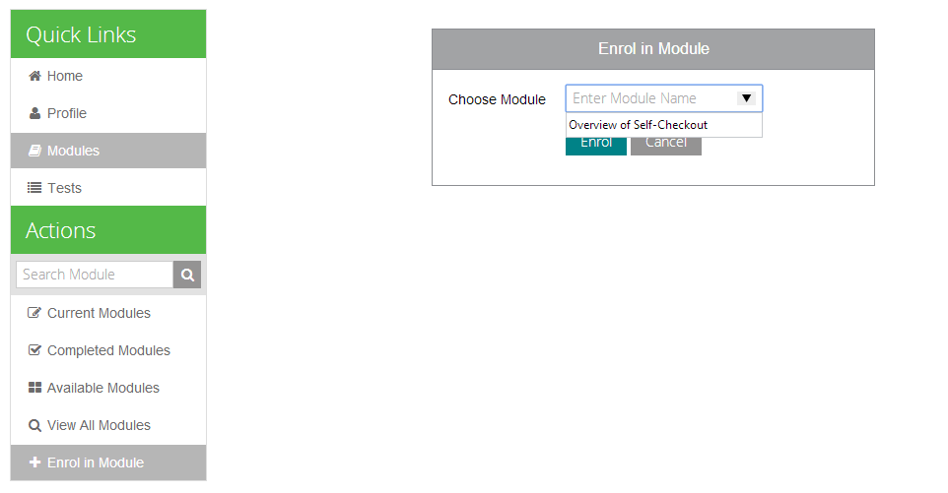

In the Enrol in Module page under Modules, you can choose a module to enrol in. Type a module title or click on the dropdown arrow to list all available modules. Click on the Enrol button to enrol in the chosen module.

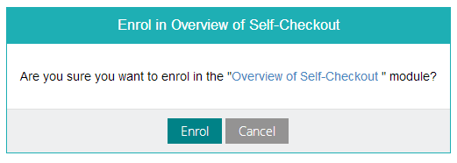 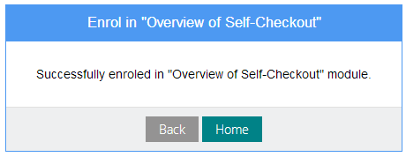

You will then be presented with a confirmation dialog. After clicking on the Enrol button, a success dialog will then be shown if the enrolment is a success.

#### Enrol Button in Module List View

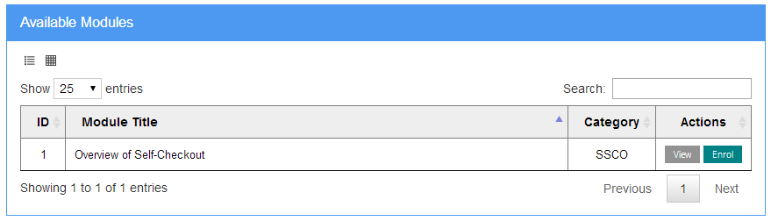

Click to Enrol

You can also enrol through the Module List View. Clicking on the Enrol Button will bring you to the confirmation dialog as shown above.

#### Through the View Module Action Pane

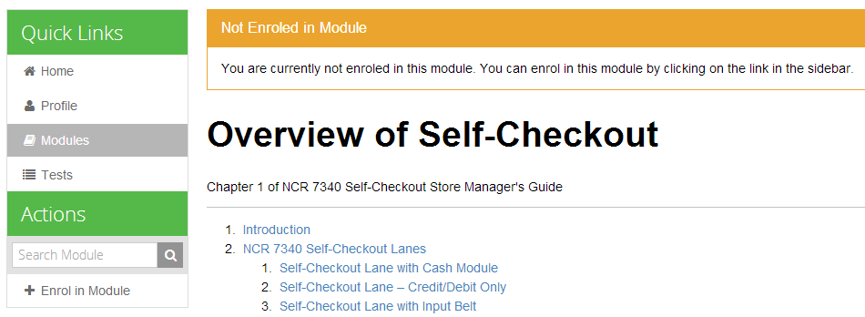

Click to Enrol

When viewing an unenrolled module, the Actions pane will show an Enrol in Module option. Clicking on this option brings you to the enrolment confirmation dialog.

### Viewing a Module

You can view a module by clicking on the View Module button. The depending on the enrolment status of a module, you can have three different notices and actions available for the module. The main module content stays the same.

#### Unenrolled Modules

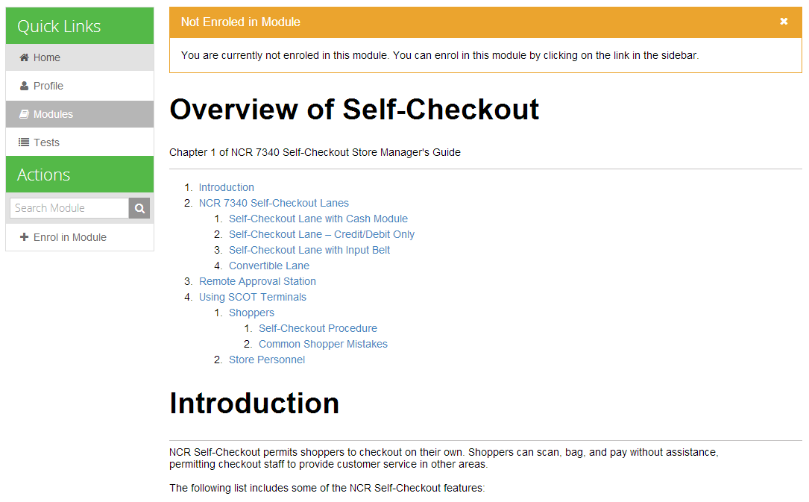

Table of Contents

Title

Description

Content

Available Actions

Notice

For unenrolled modules, you will be notified that you are not yet enrolled in the module. You will then be able to enrol in the module by clicking on the option in the Actions pane.

#### Current Modules

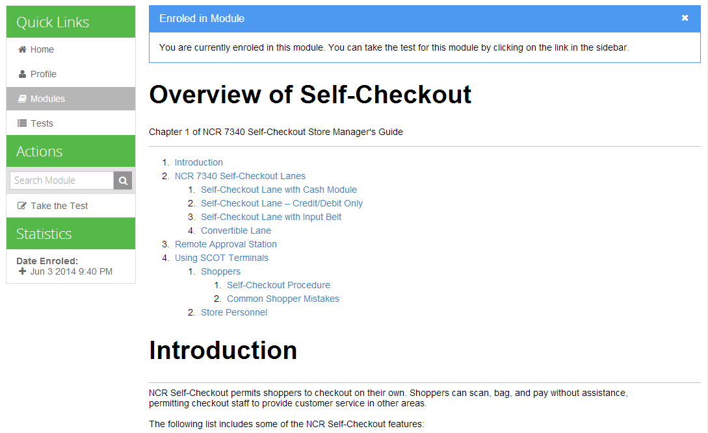

When viewing currently enrolled modules, you are given the option to take the module test. By taking the test, you will be able to complete the module. A Statistics pane also shows the enrolment date.

#### Completed Modules

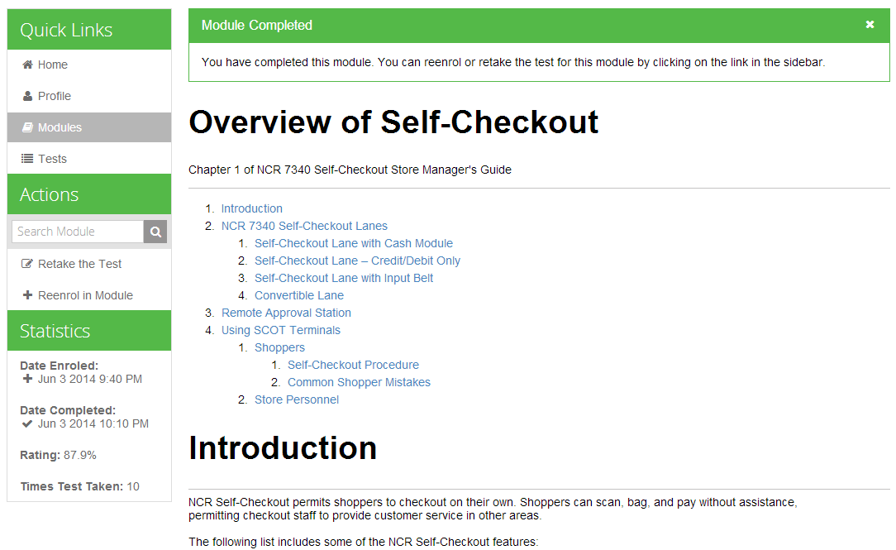

For completed modules, you will be able to retake the module’s test or even reenrol in said module. In addition, the Statistics pane will show more comprehensive information on the viewed module.

### Taking a Module Test

#### Test Form

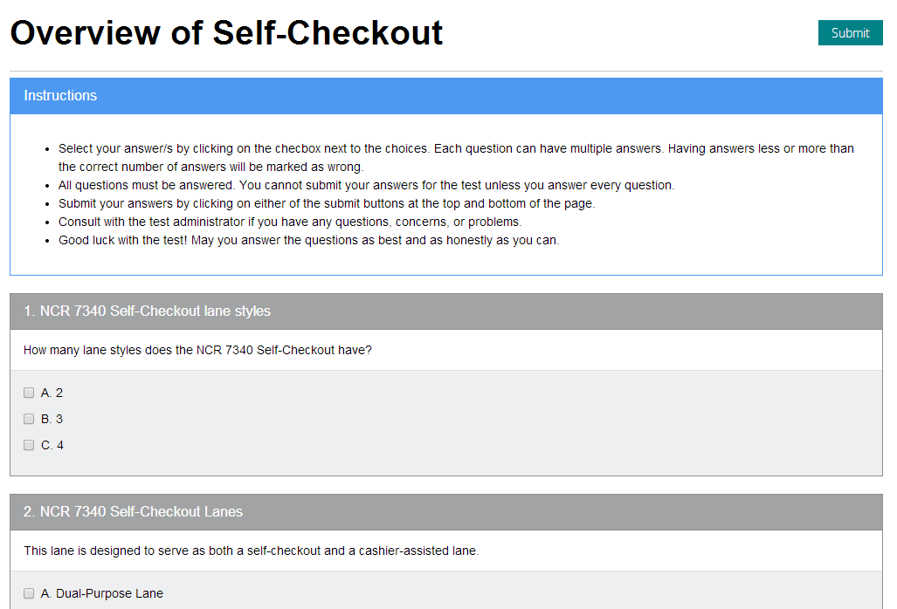

When you take the module test, you will be presented with the test form. The test will consist of at most ten random questions. Do read the instructions carefully. Please note that you may not leave the test until after you submit your answers.

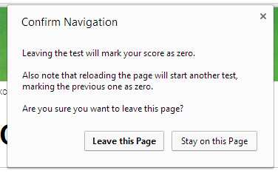

#### Test Results

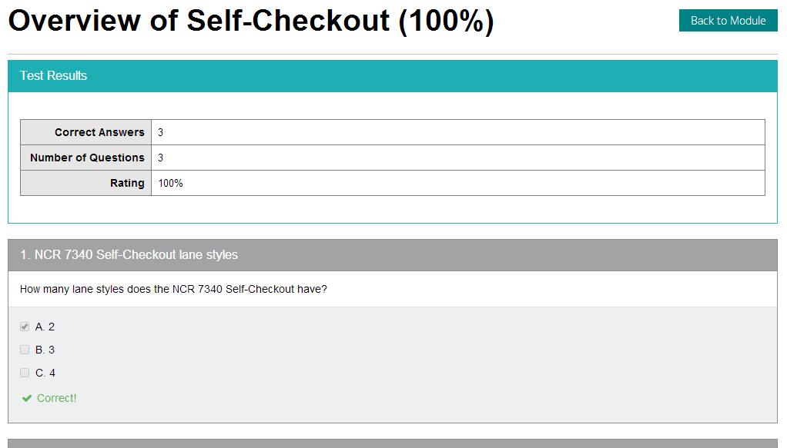

After taking the test, you will be shown the results of the test. The correct answers will not be shown, but you will at least know whether your answers are correct or not.

### Search Module

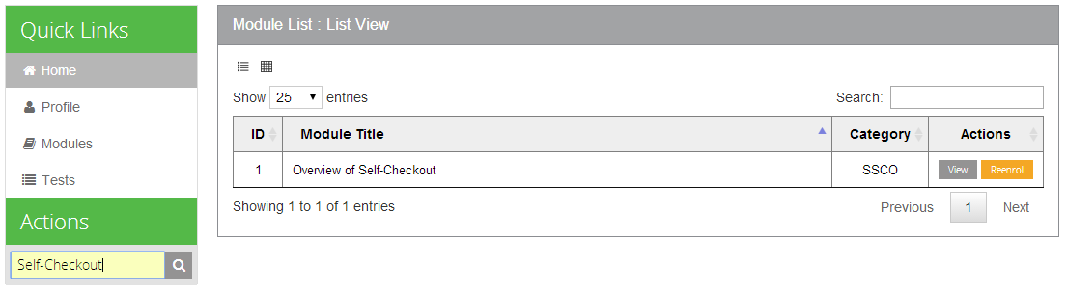

You can search for modules using the search bar in the Actions pane. You can search by title (or parts of it) or by probable tags.

## Trainee Profile

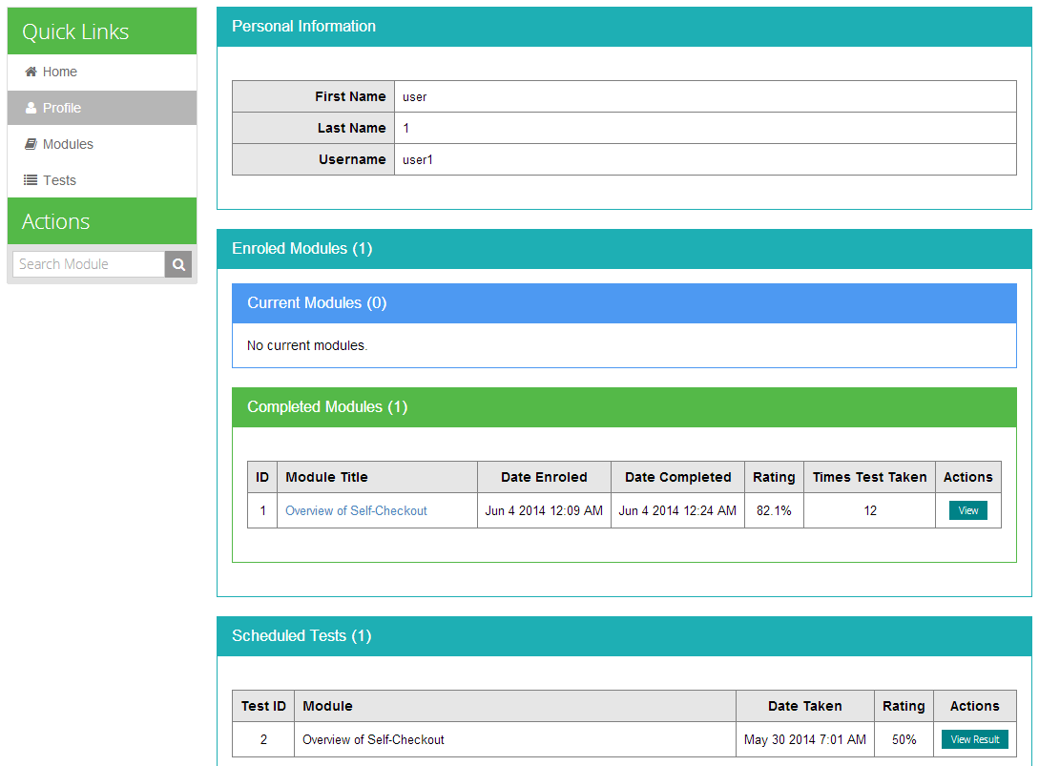

The Profile page shows a detailed summary of the modules you are enrolled in, as well as the test results of the Scheduled Tests you have taken. Scheduled Tests will be discussed under the “Scheduled Tests” section below.

## Scheduled Tests

#### Taking Scheduled Tests

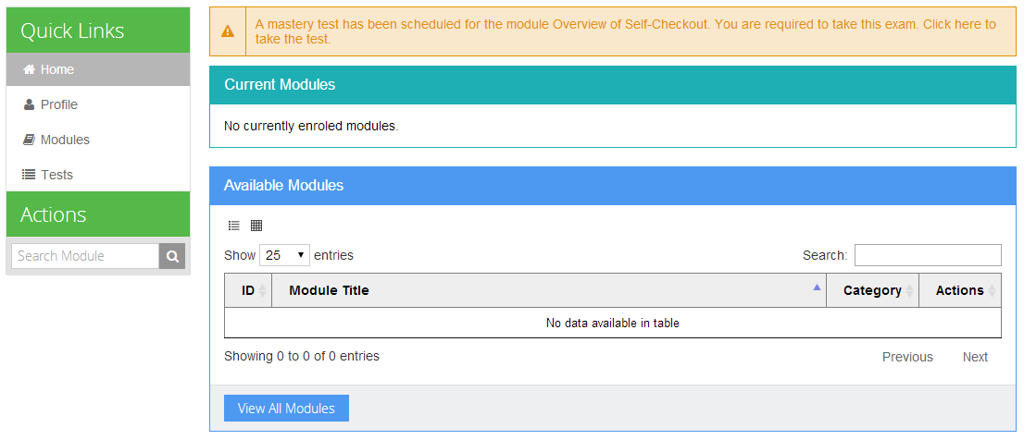

Scheduled tests are tests conducted by the administrator to evaluate your knowledge or skills regarding a topic. When a scheduled test has been conducted, a notice will be shown on the home page. Clicking the notice will take you to the test form. Alternatively, you can go to the Tests page and see the current scheduled tests as well as your previous test results.

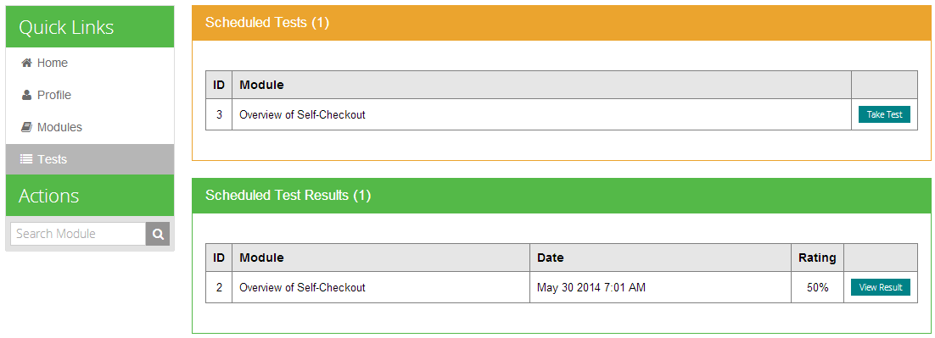

#### Test Form

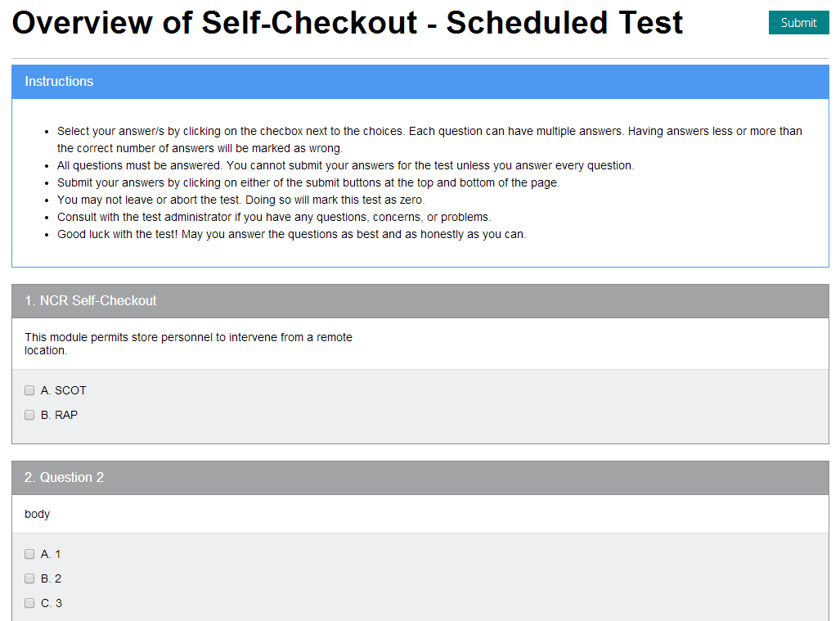

Scheduled tests are similar to the module tests for most parts. The main difference is that you cannot retake scheduled tests. Once you submit or abort the test, you will not be able to take the test again.

#### Test Results

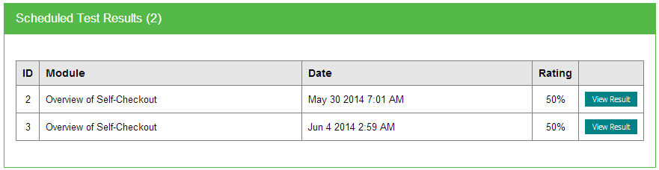

Unlike module tests, you can still view your scheduled test results even after the test is already done. Click on the View Result button to view the results of a particular scheduled test.

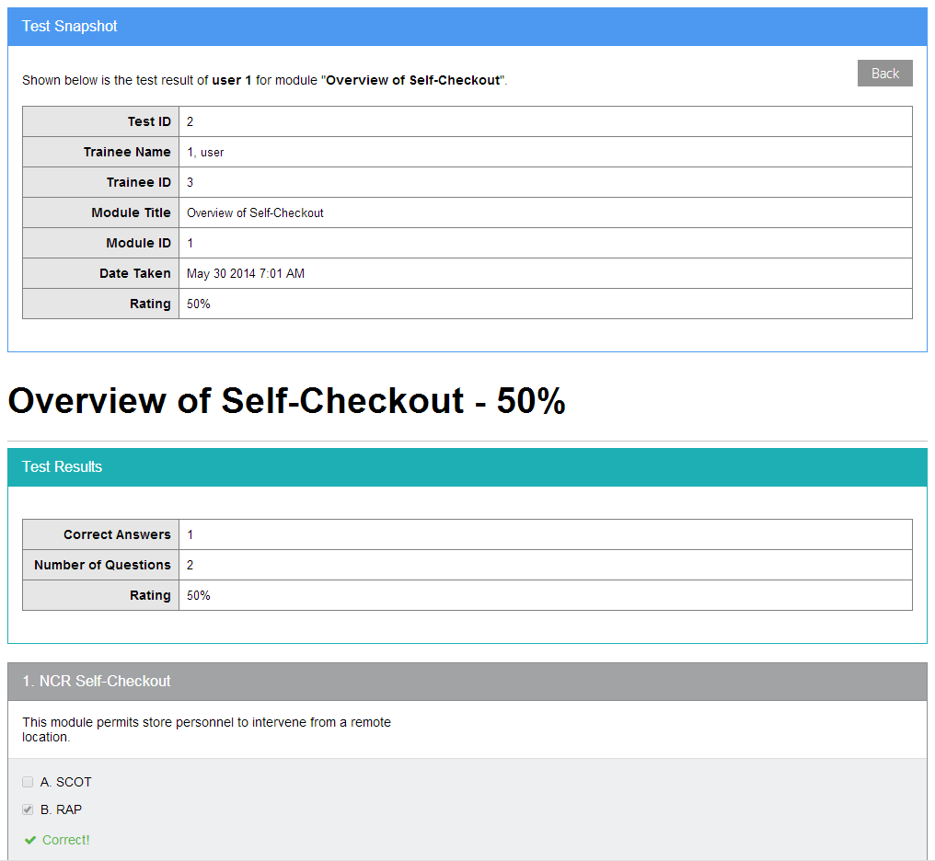

# Index

General Page Layout, 6

Main Content, 6

Sidebar, 7

Actions, 7

Quick Links, 7

Getting Started, 5

User Login, 5

Web Browser, 5

Modules, 9

Available Modules Page, 11

Grid View, 11

List View, 11

Completed Modules Page, 10

Current Modules Page, 10

Enrolling in Modules, 13

Enrol Button in Module List View, 14

Enrol in Module Page, 13

Through the View Module Action Pane, 14

Module Test, 18

Test Form, 18

Test Results, 19

Search Module, 19

Viewing a Module, 15

Completed Modules, 17

Current Modules, 16

Unenrolled Modules, 15

Viewing All Modules, 12

Scheduled Tests, 21

Taking Scheduled Tests, 21

Taking Test Form, 22

Taking Test Results, 23

Trainee Home, 8

Trainee Profile, 20